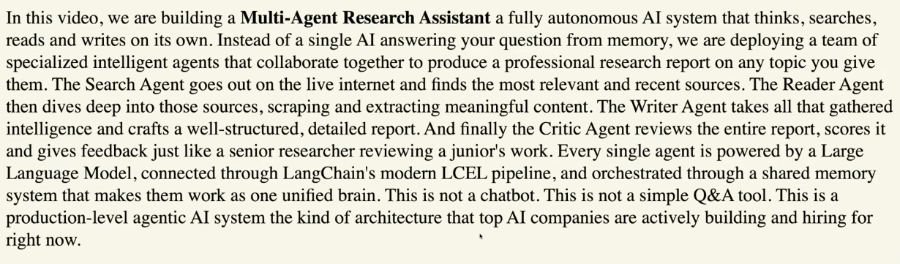

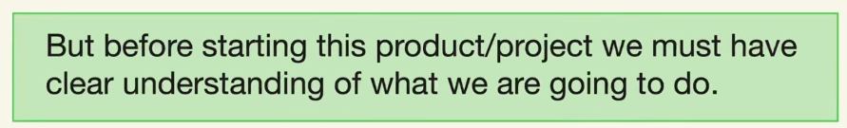
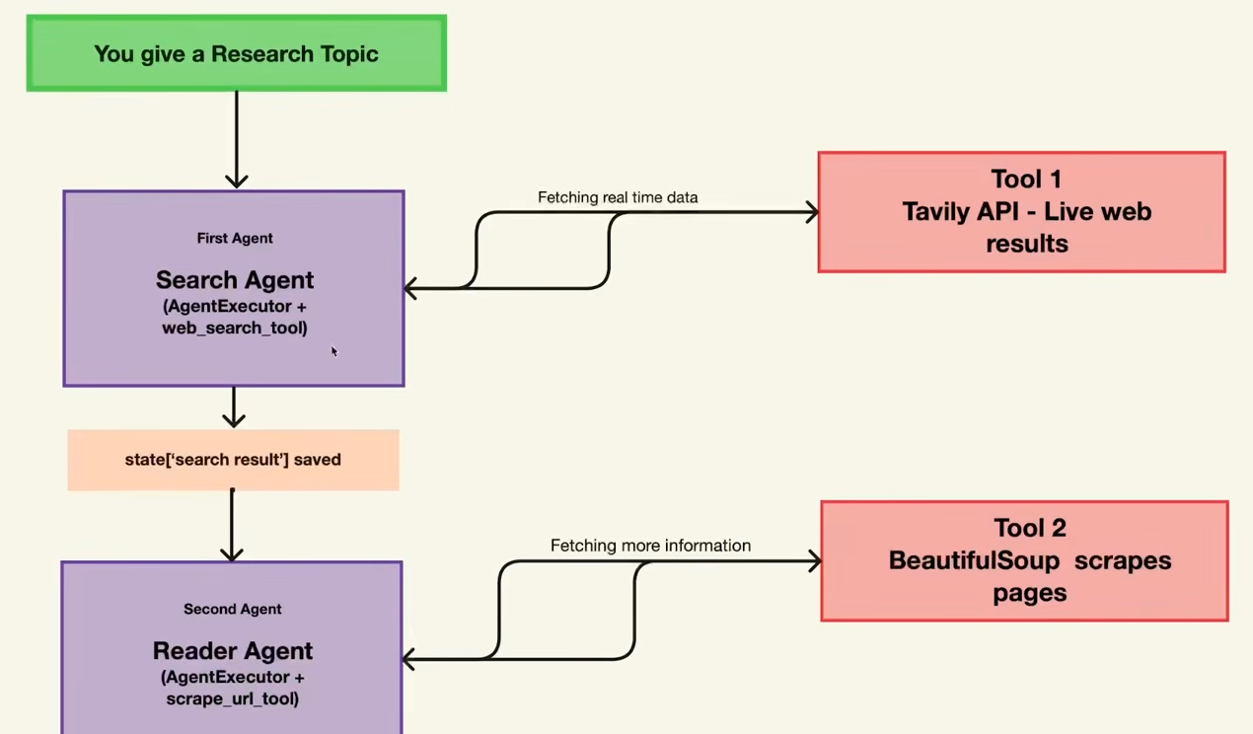

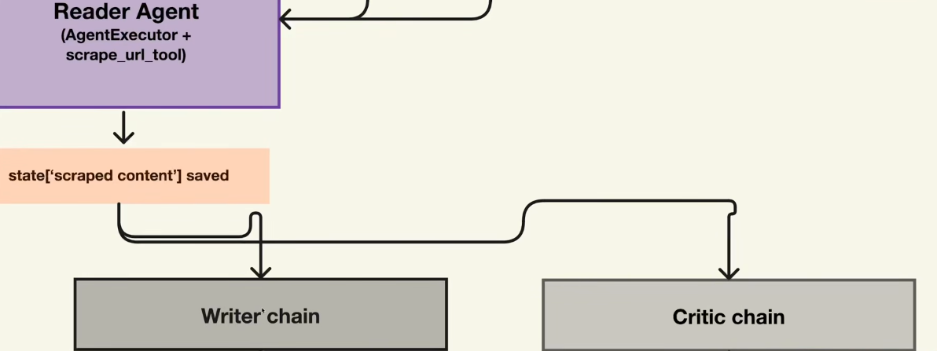

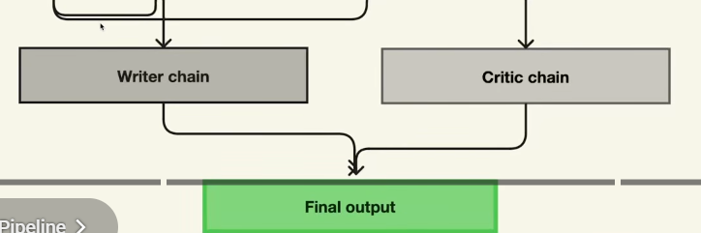

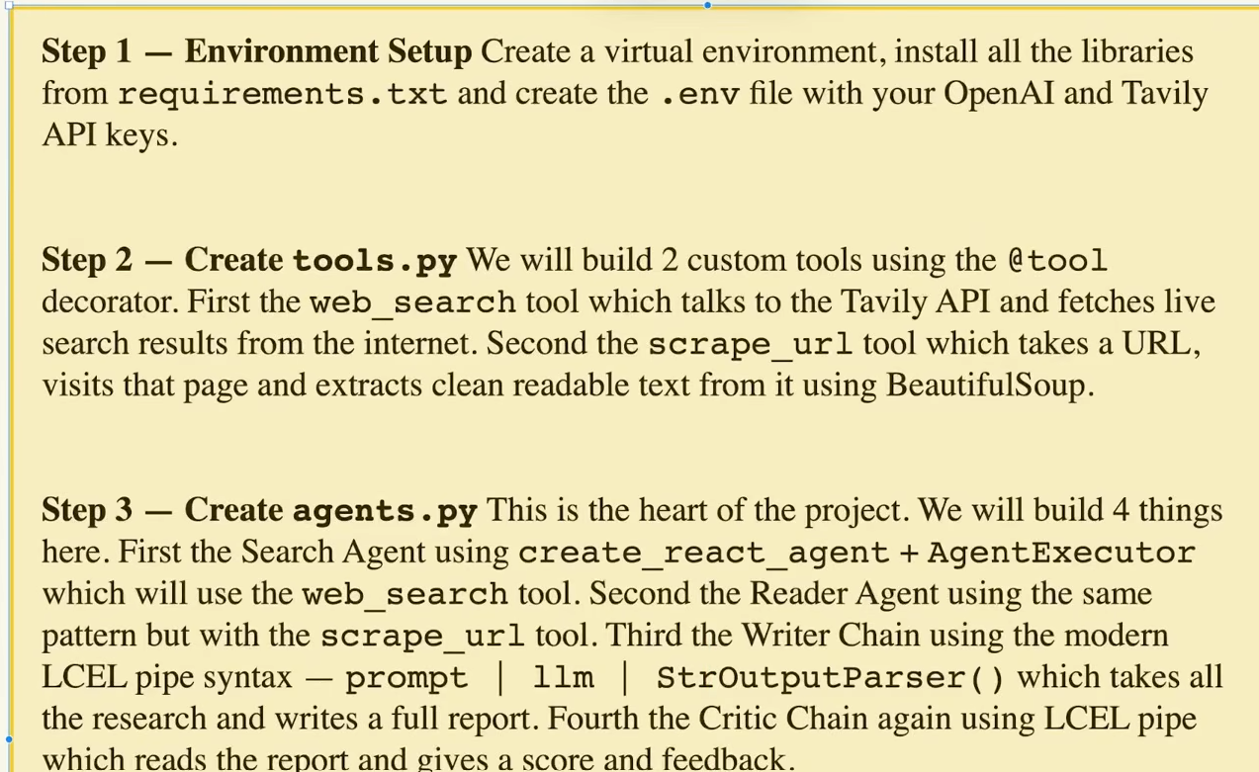

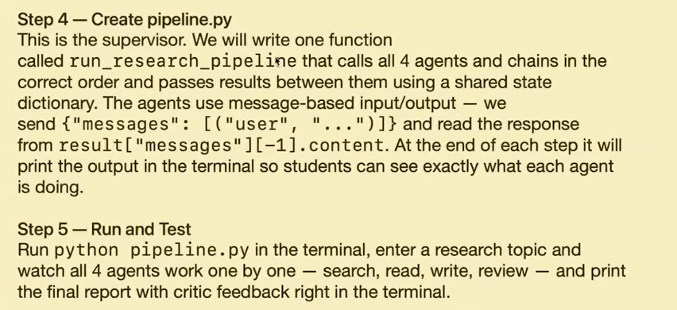

Tavily finds relevant web pages, ranks them, extracts content, and returns AI-friendly results.

BeautifulSoup is a Python HTML parser. It does not search the web. It only processes HTML that you already obtained.
One important note: join() only works with strings.
join() is a string method used to combine multiple strings into a single string

create_react_agent -OUTDATED

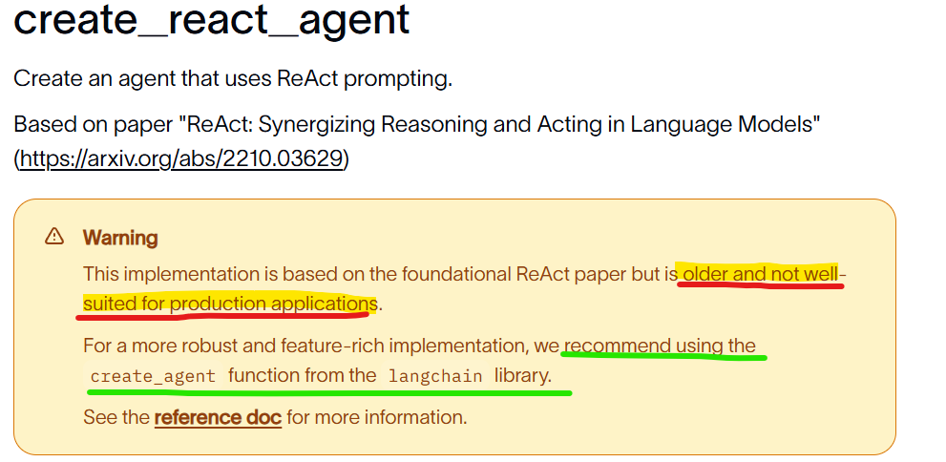

Create_react_agent sample code
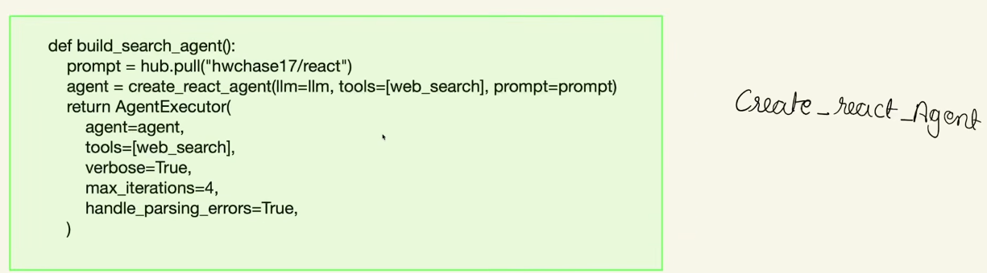

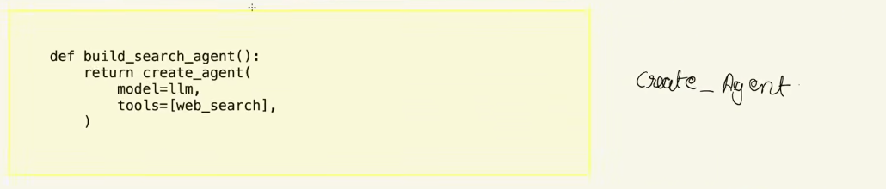

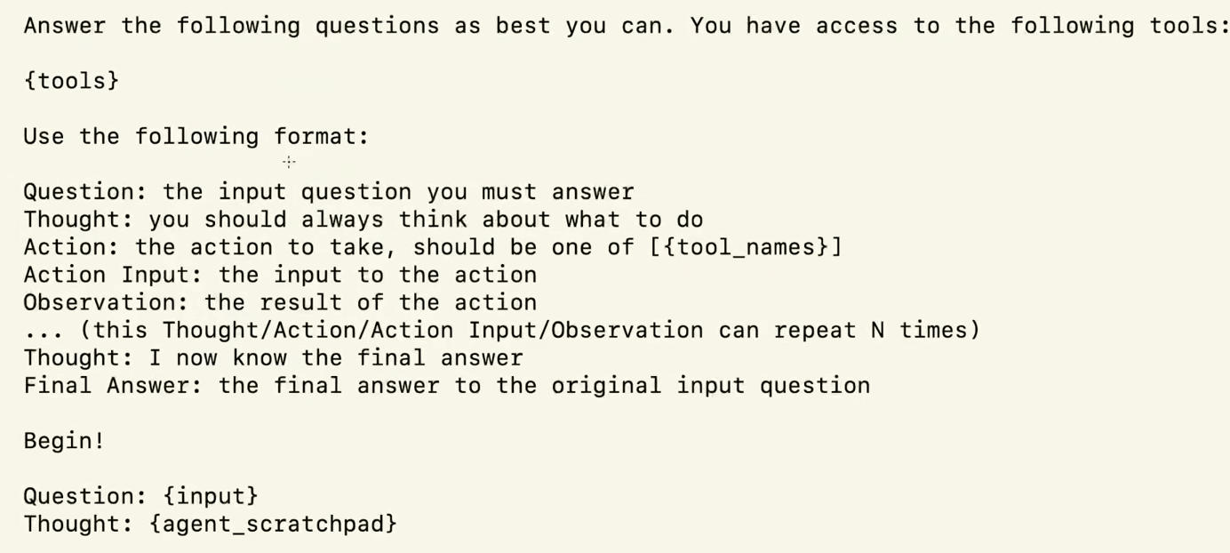

Earlier LLM was not having capabilities to detect the availability of tool during API call.
But now LLM model has that capability to automatically get the detail of tools available.

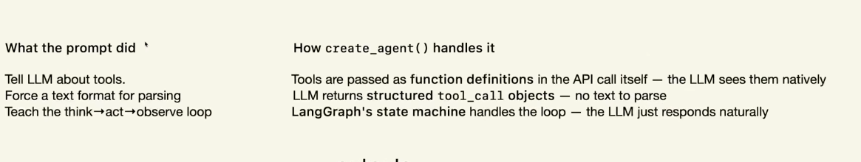

Output from an create_react_agent:
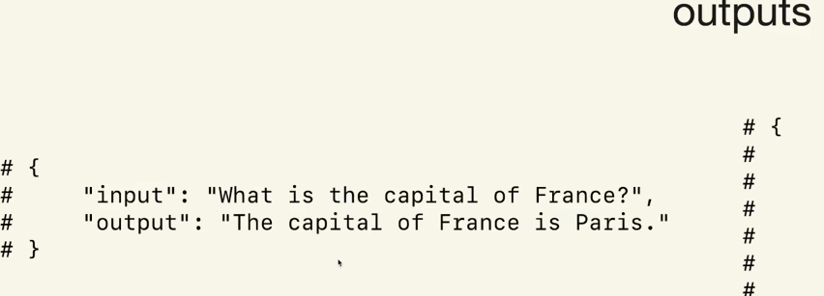
Create_agent Output:
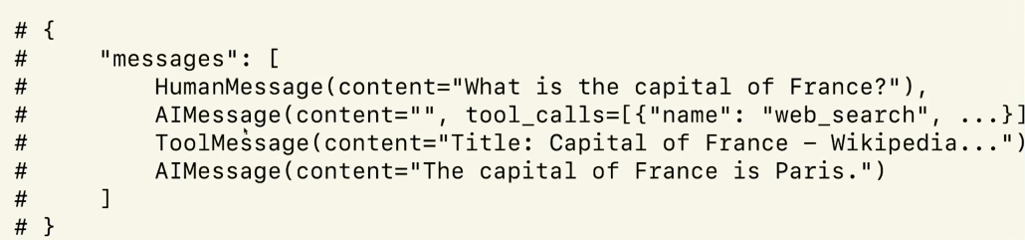

LCEL (LangChain Expression Language), it is the recommended way to build pipelines in LangChain by chaining components together using the | operator.

In create_agent, we need to define the input in below format:
